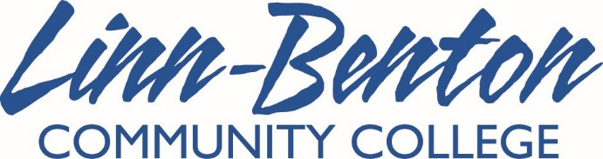

Club/Co-Curricular Donation Report Form

Instructions

When soliciting donations from local businesses, it is critical you make contact with the LBCC Foundation ahead of time. Our college has existing relationships with many companies in the area, so it’s very important you check in with them prior to approaching any local business. The Foundation must also be kept informed of all donations of products, money or services, solicited or otherwise.

- Stop by the Foundation office in the Calapooia Center 105, and talk to the staff.
- If you receive the OK, make contact with the business to request a donation. Take this form with you.
- Fill out the information below.
- Turn in the original form to the Foundation. Make a copy for the Clubs & Co-Curriculars Program Assistant in Forum-120, and a copy for yourself, if desired.

Donor Information

Business name __________________________________________________________________________

Address ________________________________________________________________________________

_______________________________________________________________________________________
Contact name _________________________________________ Contact phone _____________________

Contact email ___________________________________________________________________________

Name/description of donation (money, products, services) ________________________________________

_______________________________________________________________________________________

Real or estimated value of donation $ _________________________________________________________

Club/Co-Curricular Information

Club/co-curricular program name ____________________________________________________________

Student rep name _______________________________ Adviser name ____________________________

Student rep email ________________________________________________________________________

